National Curriculum  To develop a wide range of art and design techniques in using colour, pattern, texture, line, shape, form and space.  To develop a wide range of art and design techniques in using line, shape, form and space.  About the work of a range of artists, craft makers and designers, describing the differences and similarities between different practices and disciplines, and making links to their own work.  To use a range of materials creatively to design and make products | Key knowledge and skills to be revisited/practised in Year 1 and 2 Art:  - Types of line – horizontal, vertical, cross hatching  - Primary colours: red, yellow, blue  - Secondary colours: orange, green, purple  - Colour mixing combinations  - 2D shapes are flat, 3D shapes are solid  - Recap artists: Louis Wain, Kandinsky, Milhazes, Bridget Riley, David Hockney
 | Year A Spring 1: Art and Design Skills A
 | Key Learning | Assessment | Vocabulary
 | - Create prints by painting and stamping Lego blocks to make patterns, pictures and letters  - Explore and analyse the work of Louis Wain and the stories behind it, and then act out some of the scenes depicted  - Draw around and overlap 2D shapes to create an abstract piece, filling each shape with a different colour and medium  - Mix different hues of blue and yellow to fill a hand outline with varying shades of green and add decoration  - Develop print skills using shaving foam and ink to represent the flames and beams of Tudor houses | 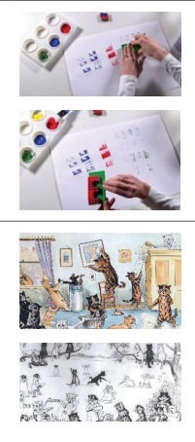  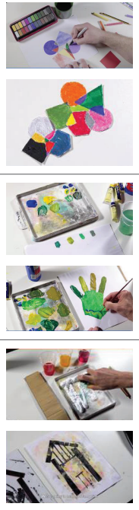 | 2D shapes  3D shapes  Abstract  Contemporary  Drawing mediums  Narrative  Printing  Shade  Tudor style house
End of unit assessment Task(s)
Assessment focus (NC) | Task(s)
 | End of unit online quiz

