National Curriculum  To use drawing, painting and sculpture to develop and share their ideas, experiences and imagination.  To develop a wide range of art and design techniques in using colour, pattern, texture, line, shape, form and space.  About the work of a range of artists, craft makers and designers, describing  the differences and similarities between different practices and disciplines, and making links to their own work | Key knowledge and skills to be revisited/practised in Year 1 and 2 Art:  - Types of line – horizontal, vertical, cross hatching  - Primary colours: red, yellow, blue  - Secondary colours: orange, green, purple  - Colour mixing combinations  - 2D shapes are flat, 3D shapes are solid  - Recap artists: Louis Wain, Kandinsky, Milhazes, Bridget Riley, David Hockney
 | Year B Spring 1: Art and design skills B
 | Key Learning | Assessment | Vocabulary
 | - Develop sculpting and modelling skills by creating textures on the surface of a clay tile  - Overlap coloured strips of paper to learn how to weave  - Create plate designs, working from Clarice Cliff’s “Circle Tree”  - Experiment with tone and shade by working in the style of Nancy McCroskey’s “Suite in Black, White and Gray”  - Develop painting skills whilst designing a roller coaster ride | 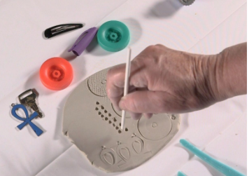  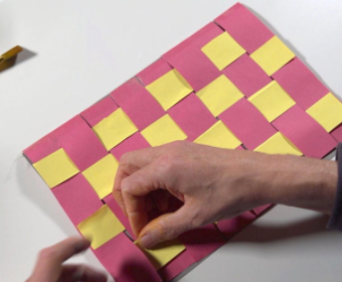  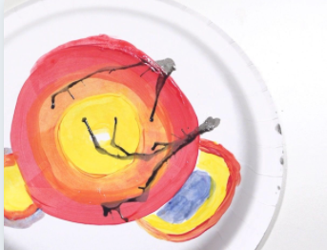  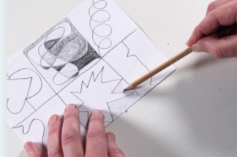  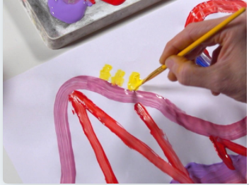 | Air drying clay  Ceramics  Concentric circles  Repeating pattern  Score  Sketch  Slip  Tone
End of unit assessment Task(s)
Assessment focus (NC) | Task(s)
As above | End of unit online quiz

