National Curriculum  To develop a wide range of art and design techniques in using colour, pattern, texture, line, shape, form and space.  To learn about the work of a range of artists, craft makers and designers, describing the differences and similarities between different practices and disciplines, and making links to their own work.  Evaluate and analyse creative works using the language of art, craft and design.  To use drawing, painting and sculpture to develop and share their ideas, experiences and imagination | Key knowledge and skills to be revisited/practised in Year 1 and 2 Art:  - Types of line – horizontal, vertical, cross hatching  - Primary colours: red, yellow, blue  - Secondary colours: orange, green, purple  - Colour mixing combinations  - 2D shapes are flat, 3D shapes are solid  - Recap artists: Louis Wain, Kandinsky, Milhazes, Bridget Riley, David Hockney
 | Year A Autumn Term: Formal Elements of Art A
 | Key Learning | Assessment | Vocabulary
 | - Use the work of Beatriz Milhazes as inspiration for creating a piece of abstract art  - Use the work of Bridget Riley as inspiration for creating a piece of art through arranging pieces of string and then drawing these through observation, using pencils and chalk  - Create a single, large piece of art as a class, inspired by water, David Hockney and Vija Celmins. Listen to music and work expressively with a variety of media  - Use play-doh to understand the primary colours, and practise mixing them to make secondary colours  - Recreate “0-9” by Jasper Johns through colour mixing | 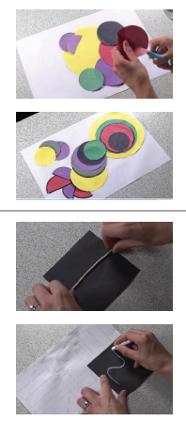  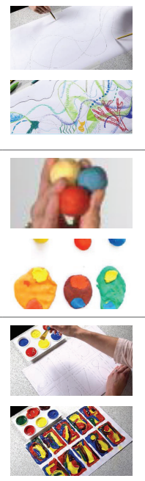 | Abstract  Composition  Shape  Photorealism  Primary colours  Secondary colours  Optical Illusions  Op art  Pop art  Modern art  Contemporary
End of unit assessment Task(s)
Assessment focus (NC) | Task(s)
As above | End of unit quiz

