National Curriculum  To use a range of materials creatively to design and make products.  To use drawing, painting and sculpture to develop and share their ideas, experiences and imagination.  To develop a wide range of art and design techniques in using colour, pattern, texture, line, shape, form and space  To use a range of materials creatively to design and make products | Key knowledge and skills to be revisited/practised in Year 1 and 2 Art:  - Types of line – horizontal, vertical, cross hatching  - Primary colours: red, yellow, blue  - Secondary colours: orange, green, purple  - Colour mixing combinations  - 2D shapes are flat, 3D shapes are solid  - Recap artists: Louis Wain, Kandinsky, Milhazes, Bridget Riley, David Hockney
 | Year B Autumn Term: Formal elements of art B
 | Key Learning | Assessment | Vocabulary
 | - Children observe patterns around them and dip objects in paint to create their own repeating patterns  - Using media of their choosing, children find interesting textures and take rubbings  - Look at the frottage work of Max Ernst and tear rubbings from the previous lesson to make pictures in this style  - Line draw a piece of ribbon and make it look 3D using gradients of pencil  - Apply understanding of tone to create a 3D drawing using pastels and chalks | 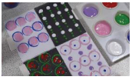  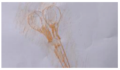  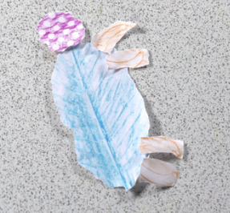  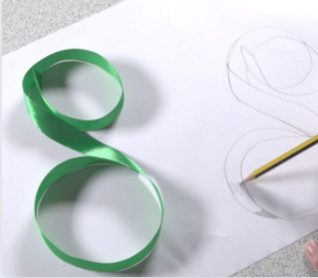  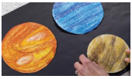 | Tessellation  Repeating pattern  Overprinting  Rubbing  Frottage  3D drawing  Dada  Surrealism  Pop art
End of unit assessment Task(s)
Assessment focus (NC) | Task(s)
As above | End of unit online quiz; final piece of work

