National Curriculum  To use a range of materials creatively to design and make products.  To develop a wide range of art and design techniques in using colour, pattern, texture, line, shape, form and space.  Be taught about the work of a range of artists, craft makers and designers, describing the differences and similarities between different practices  and disciplines, and making links to their own work | Key knowledge and skills to be revisited/practised in Year 1 and 2 Art:  - Types of line – horizontal, vertical, cross hatching  - Primary colours: red, yellow, blue  - Secondary colours: orange, green, purple  - Colour mixing combinations  - 2D shapes are flat, 3D shapes are solid  - Recap artists: Louis Wain, Kandinsky, Milhazes, Bridget Riley, David Hockney
 | Year B Spring 2: Human Form
 | Key Learning | Assessment | Vocabulary
 | - Work in groups to position bodies to make human letter forms  - Trace an image of a skull and then decorate it using a medium and pattern of choice  - Children create a collage made up of different facial features chosen and cut from magazines  - Create a self-portrait using lines and dots in the style of Julian Opie  - Make a peg figure with face, hair and clothes – work from Edwina Bridgeman | 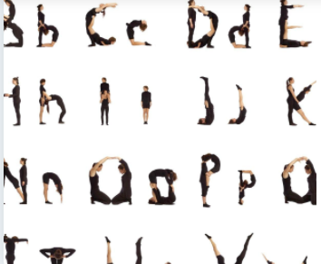  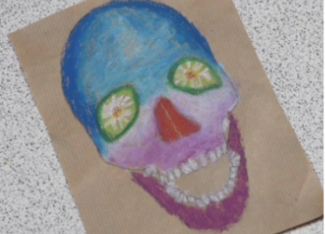  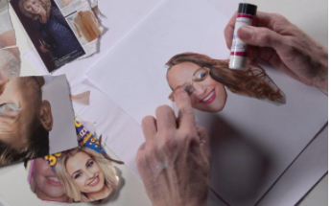  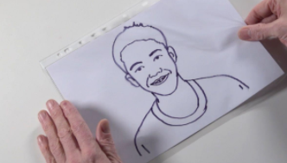  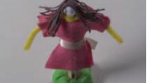 | Choreograph  Collaboration  Contemporary  Day of the Dead  Mixed media  Sculpture  Self-portrait  Symbolism
End of unit assessment Task(s)
Assessment focus (NC) | Task(s)

