National Curriculum  Use a range of materials creatively to design and make products  Use drawing, painting and sculpture to develop and share their ideas, experiences and imagination.  Learn about the work of a range of artists, craft makers and designers, describing the differences and similarities between different practices and disciplines, and making links to their own work.  Develop a wide range of art and design techniques in using colour, pattern, texture, line, shape, form and space  Use a range of materials creatively to design and make products  Become proficient in drawing, painting, sculpture and other art, craft and design  techniques | Key knowledge and skills to be revisited/practised in Year 1 and 2 Art:  - Types of line – horizontal, vertical, cross hatching  - Primary colours: red, yellow, blue  - Secondary colours: orange, green, purple  - Colour mixing combinations  - 2D shapes are flat, 3D shapes are solid  - Recap artists: Louis Wain, Kandinsky, Milhazes, Bridget Riley, David Hockney
 | Year A Spring B: Landscapes using different media
 | Key Learning | Assessment | Vocabulary
 | - Use the work of Renoir, Sorolla and Peder Severin Kroyer to consider where to place horizon and tide lines in seaside landscapes  - Use a range of materials to replicate the textures found at the seaside  - Use watercolours to create tints, shades and hues to paint the background of a seaside scene  - Paint on top of textured backgrounds with poster paint to complete a picture  - Using the watercolour background, add objects and images with detail and shading | 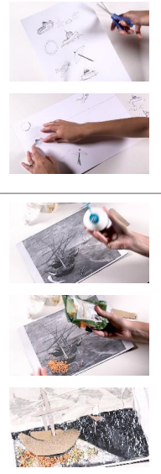  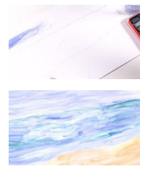  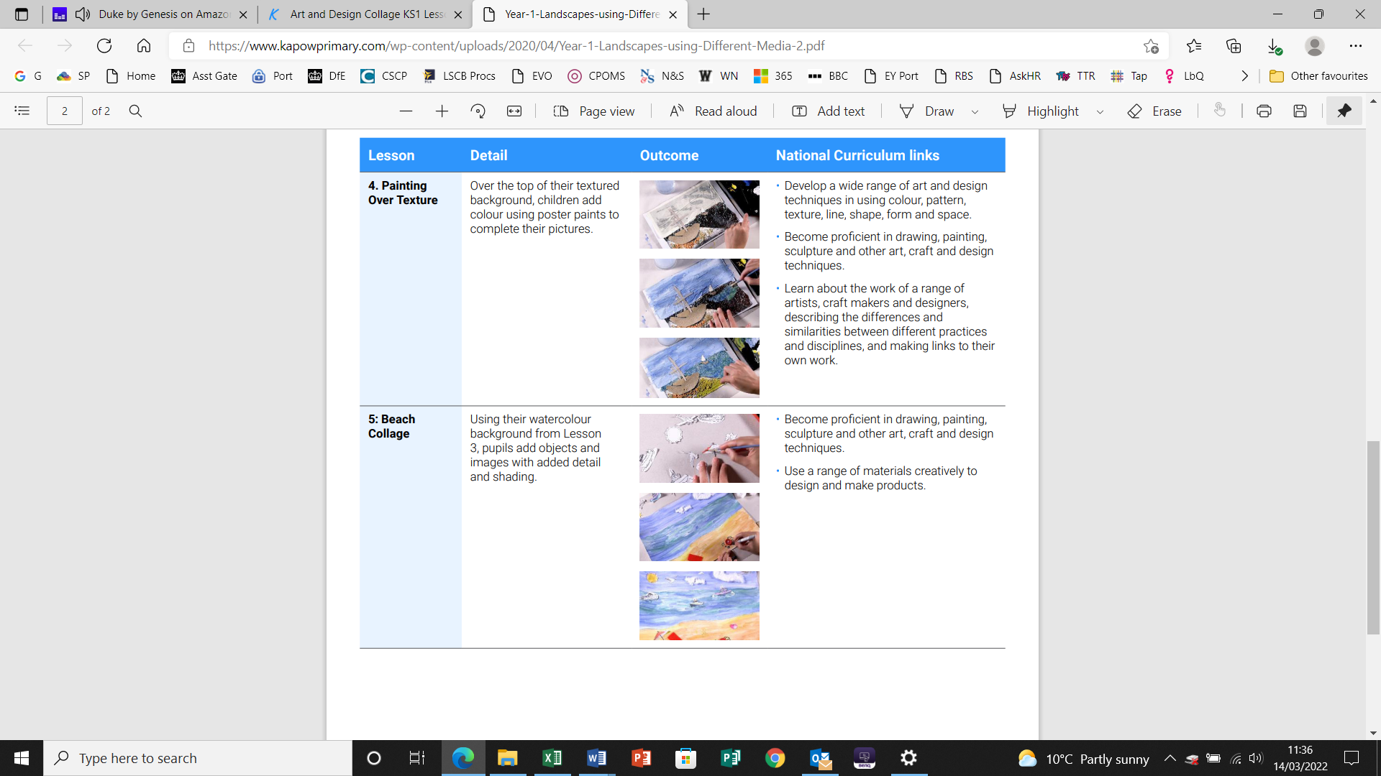 | Figurative  Horizon line  Impressionism  Landscape  Post Impressionism  Representation  Shading  Tones
End of unit assessment Task(s)
Assessment focus (NC) | Task(s)
As above | Compare their two artworks – which do the children prefer and why?  End of unit online quiz

