National Curriculum  To use a range of materials creatively to design and make products  To use drawing, painting and sculpture to develop and share their ideas, experiences and imagination to develop a wide range of art and design techniques in using colour, pattern, texture, line, shape, form and space.  Taught about the work of a range of artists, craft makers and designers  Describing the differences and  similarities between different practices and disciplines, and making links to their own work | Key knowledge and skills to be revisited/practised in Year 1 and 2 Art:  - Types of line – horizontal, vertical, cross hatching  - Primary colours: red, yellow, blue  - Secondary colours: orange, green, purple  - Colour mixing combinations  - 2D shapes are flat, 3D shapes are solid  - Recap artists: Louis Wain, Kandinsky, Milhazes, Bridget Riley, David Hockney
 | Year A Summer Term: Sculpture and Collage – living things
 | Key Learning | Assessment | Vocabulary
 | - Sketch a pattern from observation before creating a clay sculpture using etching tools  - Design and make a 3D model of a creature  - Create a 3D sculpture using objects collected from nature  - Work as a class to recreate Louise Bourgeois’ “Maman” spider sculpture  - Paint the sculpture made in the previous lesson to give it a metallic bronze effect | 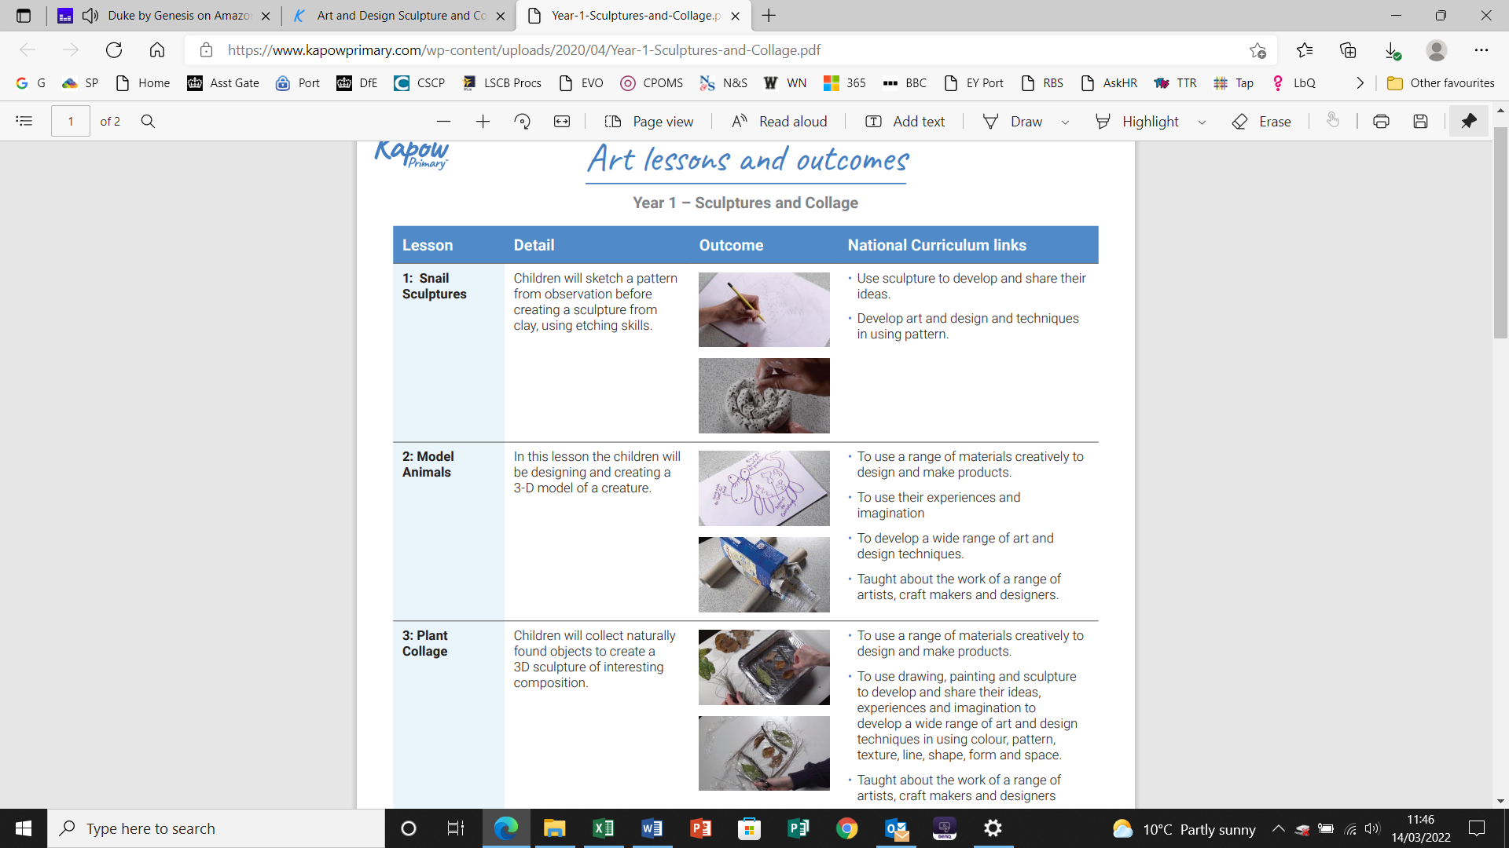  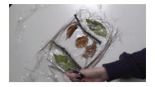  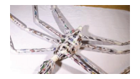  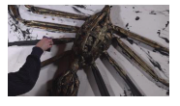 | Bronze  Contemporary  Etching  Land art  Metallic  Pattern  Sculpture  Sketch  Symmetrical  Textile
End of unit assessment Task(s)
Assessment focus (NC) | Task(s)
The work of a range of artists, craft makers and designers | End of unit online quiz

