National Curriculum  To use a range of materials creatively to design and make products.  To develop a wide range of art and design techniques in using colour, pattern, texture, line, shape, form and space  Be taught about the work of a range of artists, craft makers and designers, describing the differences and similarities between different practices  and disciplines, and making links to their own work | Key knowledge and skills to be revisited/practised in Year 1 and 2 Art:  - Types of line – horizontal, vertical, cross hatching  - Primary colours: red, yellow, blue  - Secondary colours: orange, green, purple  - Colour mixing combinations  - 2D shapes are flat, 3D shapes are solid  - Recap artists: Louis Wain, Kandinsky, Milhazes, Bridget Riley, David Hockney
 | Year B Summer: Sculpture & mixed media: superheroes
 | Key Learning | Assessment | Vocabulary
 | - Pupils pose in a “superhero” stance – partners sketch and then use wire and plasticine to make a model  - Children consider how to show emotions by making slight changes to eyes, mouth and eyebrows  - Using the work of Roy Liechtenstein, create compositions with figures, splashes and action words, with texture, definition and pattern  - Continue from previous lesson, work a colour wash into the piece and apply a dot matrix effect  - Complete works by adding bright pastels and applying a black shadow highlight | 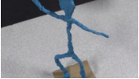  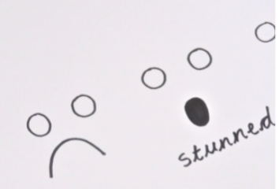  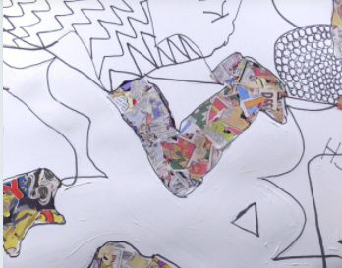  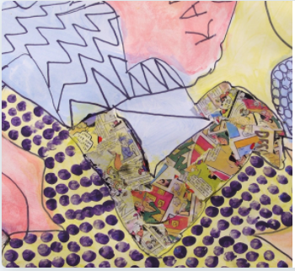  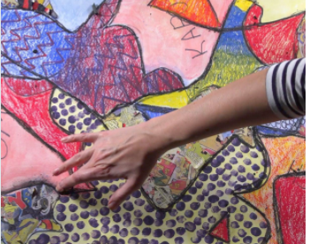 | Blend  Cartoon  Colour wash  Comic  Dot matrix  Illustrator  Pop Art  Sculpture
End of unit assessment Task(s)
Assessment focus (NC) | Task(s)
As above | End of unit online quiz

