National Curriculum  Develop their techniques, including their control and their use of materials, with creativity, experimentation and an increasing awareness of different kinds of art, craft and design  Improve their mastery of art and design techniques  Create sketchbooks to record their observations and use them to review and revisit ideas  Learn about great artists, architects and designers in history | Key knowledge and skills to be revisited/practised in Year 5 and 6 Art  -
 | Year B Autumn 1: Formal elements of art – architecture
 | Key Learning | Assessment | Vocabulary
 | - Draw a house from observation; interpret details accurately; draw what is seen, not what they think  - Create a monoprint using ink  - Add vibrant colours to an image of a house, after Hundertwasser  - Design a building, choosing how to draw it  Design a monument to commemorate something meaningful | 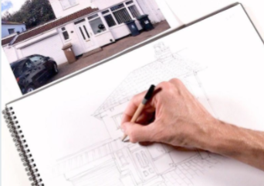  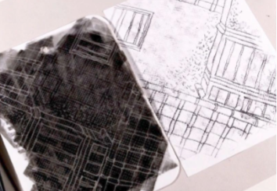  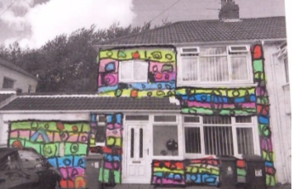  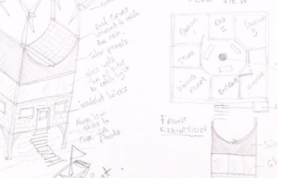  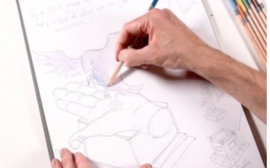 | Abstract  Amphitheatre  Ancient  Architects  Composition  Cryptic  Legacy  Monoprint  Ornate  Pattern  Plaque  Representation  Shading  Sketch  Stadium  Symbolism  Temple
End of unit assessment Task(s)
Assessment focus (NC) | Task(s)
As above | End of unit online quiz

