National Curriculum  Become proficient in drawing, painting, sculpture and other art, craft and design techniques.  Evaluate and analyse creative works using the language of art, craft and design  To improve their mastery of Art and design techniques, including drawing, painting and sculpture with a range of materials [for example, pencil, charcoal, paint, clay]  To create sketch books to record their observations and use them to review and revisit ideas | Key knowledge and skills to be revisited/practised in Year 5 and 6 Art
 | Year A Autumn term: Art and Design Skills A
 | Key Learning | Assessment | Vocabulary
 | - Extend a drawing outwards using a pencil, after Paul Klee  - Design an object that we’re missing in the world, and draw a design for it, after Da Vinci  - Draw a portrait using a continuous line, and overwrite with words from a poem  - Arrange a collection of sweet wrappers to draw, sketch the outline and add detail and colour  - Scale up previous work using a grid system  - Produce an original idea, practising sketching before producing a final drawing | 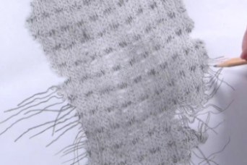  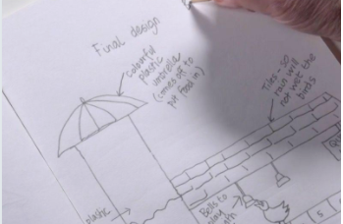  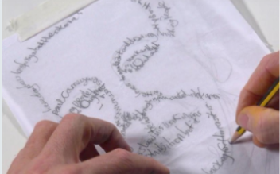  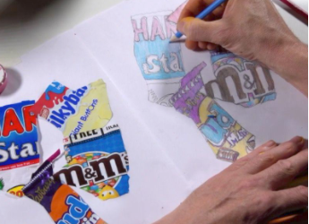  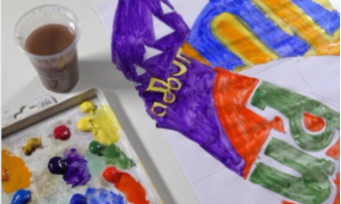  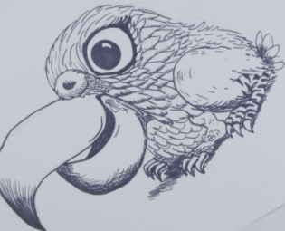 | Analytical and observational drawing  Annotation  Collage  Computer aided design  Continuous line drawing  Diagram  Exploded diagrams  Invention  Portrait  Prototypes  Sketch  Texture
End of unit assessment Task(s)
Assessment focus (NC) | Task(s)

