National Curriculum  Become proficient in drawing, painting, sculpture and other art, craft and design techniques  Evaluate and analyse creative works using the language of art, craft and design  To improve their mastery of art and design techniques  Design purposeful, functional, appealing products for themselves and other users  Based on design criteria generate, develop, model and communicate their ideas through talking, drawing,  templates, mock-ups and, where appropriate, information and communication technology | Key knowledge and skills to be revisited/practised in Year 5 and 6 Art
 | Year B Summer 2: Design for a purpose
 | Key Learning | Assessment | Vocabulary
 | - Learn about coats of arms and create own  - Working to a brief, children work collaboratively to create a design for an empty room  - Cut out shapes to help experiment and develop design ideas  - Devise a product from a product name starting point  - Create and present a pitch to sell a product  - | 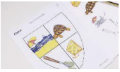  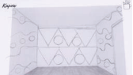  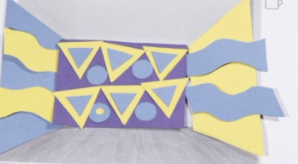  I understand how advertising, words, USP and packaging help to sell a product  I communicate through spoken and visual language to sell a USP | Client  Collaborative  Consumable  Design brief  Font  Heraldry  Logo  Pitch  Presentation  Prototype  Sketch  Slogan  Soundbite  Template  Urban  USP
End of unit assessment Task(s)
Assessment focus (NC) | Task(s)
As above | End of unit online quiz

