National Curriculum  Become proficient in drawing, painting, sculpture and other art, craft and design  Techniques  Evaluate and analyse creative works using the language of art, craft and design  To improve their mastery of art and design techniques, including drawing, painting and sculpture with a range of  materials [for example, pencil, charcoal, paint, clay]  Know about great artists, architects and designers in history | Key knowledge and skills to be revisited/practised in Year 5 and 6 Art
 | Year B Spring 2/Summer 1: Every Picture Tells a Story
 | Key Learning | Assessment | Vocabulary
 | - Look at a piece of work by Banksy, understand the message, and innovate on it  - Create symmetrical ink drawings after Warhol’s “Rorschach”  - Use emojis to create sentences and create meaning  - Use “Gassed” by John Singer Sargent to explore the human side fo the image; recreate the piece in groups and photograph  - Use Magdalene Odundo to create ideas using two colours of chalk and sweeping arm movements | 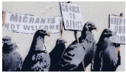  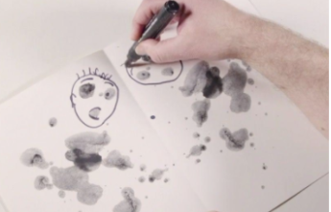    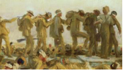  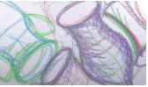 | Abstract art  Anonymous  Brexit  Emojis  Immigration  Mural  Pictograms  Racism  Street art  Symmetrical
End of unit assessment Task(s)
Assessment focus (NC) | Task(s)
As above | End of unit online quiz

