National Curriculum  Pupils should be taught to develop their techniques, including their control and  their use of materials, with creativity, experimentation and an increasing awareness of different kinds of art, craft  and design  To improve their mastery of Art and design techniques, including drawing, painting and sculpture with a range of materials [for example, pencil, charcoal, paint, clay].  About great artists, architects and designers in history. | Key knowledge and skills to be revisited/practised in Year 5 and 6 Art  -
 | Year A Spring 1: Make My Voice Heard
 | Key Learning | Assessment | Vocabulary
 | - To create graffiti art  - To draw portraits showing emotions, after Kollwitz  - To understand some of the symbolism used in “Guernica” and create an impactful piece of art  - To use paint to produce a finished piece in the style of Guernica  - To create a sculpture of a head using clay, and ideas from earlier in this unit | 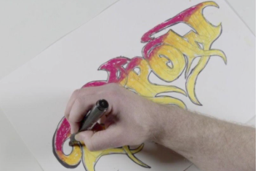  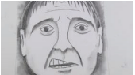  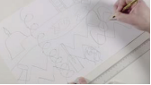  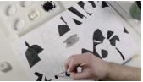  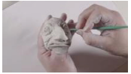 | Abstract  Chiaroscuro  Composition  Figurative  Graffiti Art  Parallel lines  Serif  Symbolism  Tag
End of unit assessment Task(s)
Assessment focus (NC) | Task(s)
As above | End of unit online quiz

