National Curriculum  Become proficient in drawing, painting, sculpture and other art, craft and design  Techniques  Evaluate and analyse creative works using the language of art, craft and design  To improve their mastery of art and design techniques | Key knowledge and skills to be revisited/practised in Year 5 and 6 Art  -
 | Year A Summer 1: Photography
 | Key Learning | Assessment | Vocabulary
 | - To create a photo montage using secondary source photographs  - To use text and image together to create meaningful and powerful photo posters  - To understand abstract art through photography, after Edward Weston  - To develop a self portrait from a photograph and translate it into a drawing  - To replicate the mood and expression of a painting through photography, using “The Scream” | 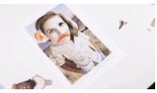  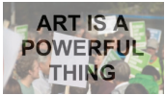  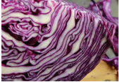  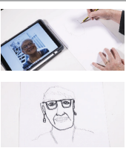  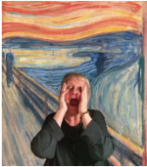 | Composition  Contrast  Crop  Digital  Expression  Lens  Macro  Photography  Self portrait  Technique  Truism
End of unit assessment Task(s)
Assessment focus (NC) | Task(s)
As above | End of unit online quiz

