National Curriculum  Develop their techniques, including their control and their use of materials,  with creativity, experimentation and an increasing awareness of different kinds of art, craft and design.  Improve their mastery of art and design techniques, including drawing, painting  and sculpture with a range of materials [for example, pencil, charcoal, paint, clay] | Key knowledge and skills to be revisited/practised in Year 5 and 6 Art  Practising shading  - Identifying reflections, symmetry and repeating patterns  - Revisit tints and shades  - Revisiting artists’ work: Cezanne, Monet, Hopper,
 | Year A Summer 2: Still Life
 | Key Learning | Assessment | Vocabulary
 | - To sketch ideas for a still life study  - To create a charcoal still life, after Carmago  - To create a still life through focusing on negative light and shade  - Paint still life in the style of Cezanne, using tints and hues  - Showcase still life works by creating a memory box | - Drawing with attention to form, line and layout  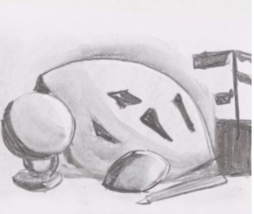  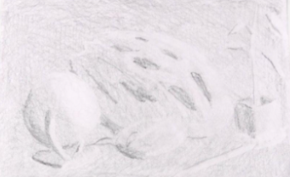  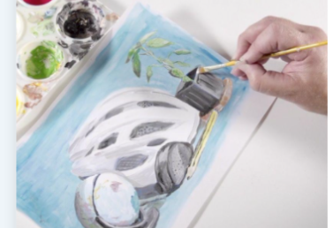  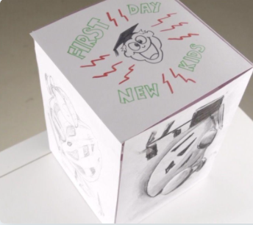 | Cartoon  Graphic  Charcoal  Colour wheel  Composition  Greyscale  Hue  Negative image  Sketching  Still life  Underpainting  Visual minutes
End of unit assessment Task(s)
Assessment focus (NC) | Task(s)
As above | End of unit online quiz

