National Curriculum  Produce creative work, exploring their ideas and recording their experiences  Evaluate and analyse creative works using the language of art, craft and design  Know about great artists, craft makers and designers, and understand the historical and cultural development of their art form  • To improve their mastery of Art and design techniques, including drawing, painting and sculpture [for example,  pencil, charcoal, paint, clay] | Key knowledge and skills to be revisited/practised in Year 3 and 4 Art  - Finding simple shapes within more complex objects  - Practising shading  - Identifying reflections, symmetry and repeating patterns  - Revisit tints and shades  - Revisiting artists’ work: Perez Ojeda, Cezanne, Hepworth,
 | Year A Autumn 2: Art and design skills A
 | Key Learning | Assessment | Vocabulary
 | - Create an optical illusion by cutting two images into strips and arranging them – after Luz Perez Ojeda  - Apply understanding of tone and tint to create a willow pattern style plate  - Work in the style of Cezanne and learn how he influenced the shift to modern art  - Carve soap into a sculpture using a variety of tools  - Arrange a collection of objects and then sketch after the still life works of Giorgio Morandi  - Learn about the role of a curator and curate their own exhibition | 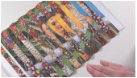  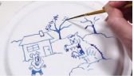  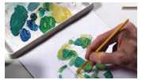  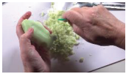  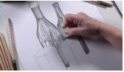  Children work in groups to select objects and create an exhibition of them | Lenticular prints  Optical illusion  Score  Sequential order  Thematic
End of unit assessment Task(s)
Assessment focus (NC) | Task(s)
As above | End of unit online quiz

