National Curriculum  Pupils should be taught to develop their techniques, including their control and  their use of materials, with creativity, experimentation and an increasing awareness of different kinds of art, craft  and design.  About great artists, architects and designers in history  To create sketch books to record their observations and use them to review and revisit ideas  To improve their mastery of Art and design techniques, including drawing, painting and sculpture [for example,  pencil, charcoal, paint, clay] | Key knowledge and skills to be revisited/practised in Year 3 and 4 Art  - Finding simple shapes within more complex objects  - Practising shading  - Identifying reflections, symmetry and repeating patterns  - Revisit tints and shades  - Revisiting artists’ work:Cezanne, Hepworth, Perez Odeja  - Primary and secondary colours
 | Year B Spring Term: Art and design skills B
 | Key Learning | Assessment | Vocabulary
 | - Draw a family having a meal in a cartoon style using Carl Giles  - Learn that a tint is made by adding white and shade by adding black  - Sketch a soft toy  - Make a puppet mouse using a polystyrene ball, paints, card, dowel rods and felt – using “The Dark at the Top of the Stairs” by Sam McBratney  - Create shadow puppets, make a puppet theatre and perform | 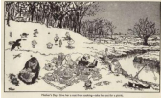  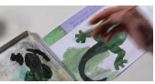  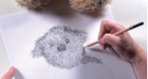  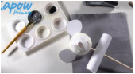  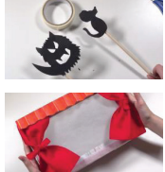 | Cartoonist  Character  Minimal  Opaque  Puppet  Sketching  Style  Three dimensional  Tint  Sone  Shade
End of unit assessment Task(s)
Assessment focus (NC) | Task(s)
As above | End of unit online quiz

