National Curriculum  Develop their techniques, including their control and their use of materials, with creativity, experimentation and an increasing awareness of different kinds of art, craft and design.  Create sketch books to record their observations and use them to review and revisit ideas  Improve their mastery of art and design techniques  Learn about great artists, architects and designers in history | Key knowledge and skills to be revisited/practised in Year 3 and 4 Art  - Finding simple shapes within more complex objects  - Practising shading  - Identifying reflections, symmetry and repeating patterns  - Revisit tints and shades  - Revisiting artists’ work: Cezanne, Hepworth, Perez Odeja  - Primary and secondary colours
 | Year B Summer Term: Craft
 | Key Learning | Assessment | Vocabulary
 | - Create fabrics, colours, textures and images to make a mood board  - Learn how to create tie-dye patterns  - Use the work of Anni Albers to make a weave  - Weave with fabric using a loom  - Sew a shape or fabric weave on to the front of their tie-dyed t-shirt | 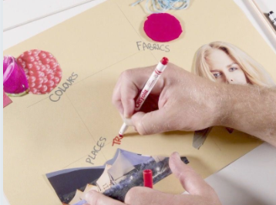  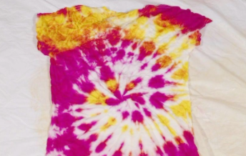  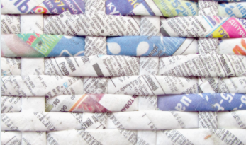  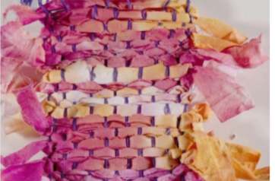  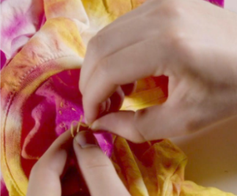 | Interior designer  Intersection points  Loom card frame  Mood board  Personality  Running stitch  Synthetic materials  Textile designer  Warp  Wax resist  Weave  Weft
End of unit assessment Task(s)
Assessment focus (NC) | Task(s)
As above | End of unit online quiz

