National Curriculum  To develop their techniques, including their control and their use of materials, with creativity, experimentation and an increasing awareness of different kinds of art, craft and design.  To improve their mastery of Art and design techniques, including drawing,painting and sculpture [for example,  pencil, charcoal, paint, clay] | Key knowledge and skills to be revisited/practised in Year 3 and 4 Art  - Finding simple shapes within more complex objects  - Practising shading  - Identifying reflections, symmetry and repeating patterns  - Revisit tints and shades  - Revisiting artists’ work: Cezanne, Hepworth, Perez Odeja  - Primary and secondary colours
 | Year A Autumn 1: Formal Elements of Art A
 | Key Learning | Assessment | Vocabulary
 | - Identifying simple shapes that make up objects found around school  - Learn to study an object to identify the simple geometric shapes it is made up of and sketch out the details  - Bend and twist wire to create a fish  - Learn and apply the four rules of shading  - Practice shading smoothly from light to dark | 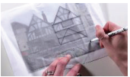  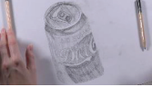  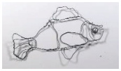  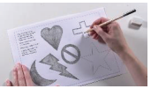  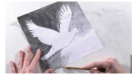 | 3D form  Facial features  Geometric shapes  Guidelines  Shading  Sketching  Template  Tones
End of unit assessment Task(s)
Assessment focus (NC) | Task(s)
As above | End of unit online quiz  Final shaded piece of work

