National Curriculum  To create sketchbooks to record their observations and use them to review and revisit ideas.  To improve their mastery of Art and design techniques, including drawing, painting and sculpture [for example,  pencil, charcoal, paint, clay]  To develop their techniques, including their control and their use of materials, with creativity, experimentation and an increasing awareness of different kinds of art, craft and design. | Key knowledge and skills to be revisited/practised in Year 3 and 4 Art  - Finding simple shapes within more complex objects  - Practising shading  - Identifying reflections, symmetry and repeating patterns  - Revisit tints and shades  - Revisiting artists’ work: Cezanne, Hepworth, Perez Odeja  - Primary and secondary colours
 | Year B Autumn 2: Formal Elements of Art B
 | Key Learning | Assessment | Vocabulary
 | - Experiment with charcoal and then abstractly represent words and phrases  - Imprint texture and pattern into playdough using clay tools and everyday objects, then create prints  - Make stamps by drawing around geometric shapes onto polystyrene foam , and then create repeating patterns  - Use reflection and symmetry to create a “flip” pattern  - Create “The Flower of Life” geometric symbol through using compasses | 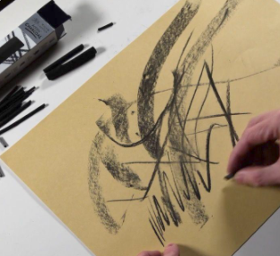  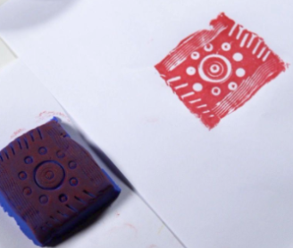  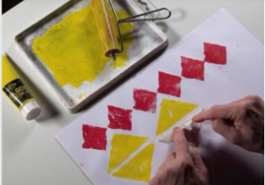  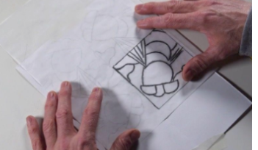  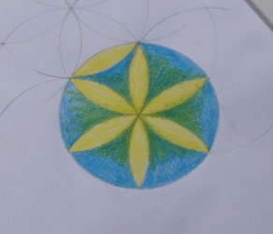 | 2D shapes  Abstract  Charcoal  Pattern  Reflection  Symmetrical  Texture
End of unit assessment Task(s)
Assessment focus (NC) | Task(s)
As above | End of unit online quiz

