National Curriculum  Create sketchbooks to record their observations and use them to review and revisit ideas  Know about great artists, craft makers and designers, and understand the historical and cultural development of  their art forms  Develop their techniques, including their control and their use of materials, with creativity, experimentation and an increasing awareness of different kinds of art, craft and design  Improve their mastery of art and design techniques, including drawing, painting and sculpture [for example, pencil, charcoal, paint, clay]. | Key knowledge and skills to be revisited/practised in Year 3 and 4 Art  - Finding simple shapes within more complex objects  - Practising shading  - Identifying reflections, symmetry and repeating patterns  - Revisit tints and shades  - Revisiting artists’ work: Cezanne, Hepworth, Perez Odeja  - Primary and secondary colours
 | Year B Autumn 1: Prehistoric art
 | Key Learning | Assessment | Vocabulary
 | - Reflect on the purpose of cave drawings, develop their sense of proportion in drawing  - Experiment with colours and effects that can be made using natural materials, and make paints using spices and found objects  - Learn to scale up drawings and use charcoal  - Paint the prehistoric animal picture drawn earlier  - Collaboratively develop a prehistoric-inspired piece, creating hand prints on a textured background | 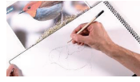  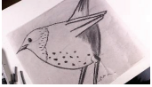  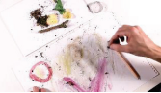  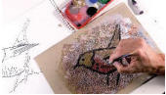  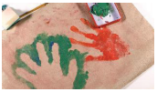 | Cave artists  Charcoal  Geometric shapes  Iron age  Line drawings  Native  Prehistoric  Proportions  Stone age  Texture  Tone
End of unit assessment Task(s)
Assessment focus (NC) | Task(s)
As above | End of unit online quiz

