National Curriculum  Develop their techniques, including their control and their use of materials,  with creativity, experimentation and an increasing awareness of different kinds of art, craft and design  Create sketch books to record their observations and use them to review and revisit ideas.  Improve their mastery of art and design techniques.  Learn about great artists, architects and designers in history | Key knowledge and skills to be revisited/practised in Year 3 and 4 Art  - Finding simple shapes within more complex objects  - Practising shading  - Identifying reflections, symmetry and repeating patterns  - Revisit tints and shades  - Revisiting artists’ work:Cezanne, Hepworth, Perez Odeja  - Primary and secondary colours
 | Year A Summer Term: Sculpture
 | Key Learning | Assessment | Vocabulary
 | - Create maracas using plastic bottles  - Recycle metal tins into drums using wax resist techniques  - Create a fruity face collage after Arcimboldo  - Create a sculpture using the work of Sokari Douglas  - Create a sculpture using the work of El Anatsui | 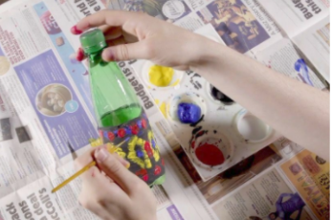  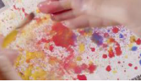  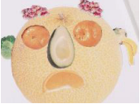    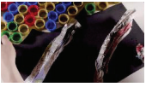 | Composition  Geometric pattern  Optical effect  Sketch  Wax resist  Upcycle  Recycle  Contrast
End of unit assessment Task(s)
Assessment focus (NC) | Task(s)
As above | End of unit online quiz

